# Week-2

**TDD using JUnit5 and Mockito**

**Exercise 1: Setting Up JUnit**

#### Calculator.java

public class Calculator {

public int add(int a, int b) {

return a + b;

}

}

#### CalculatorTest.java

import static org.junit.jupiter.api.Assertions.*;

import org.junit.jupiter.api.*;

public class CalculatorTest {

Calculator calculator;

@BeforeEach

public void setUp() {

calculator = new Calculator();

}

@AfterEach

public void tearDown() {

calculator = null;

}

@Test

public void testAddition() {

// Arrange

int a = 2, b = 3;

// Act

int result = calculator.add(a, b);

// Assert

assertEquals(5, result);

}

}

**Output:**

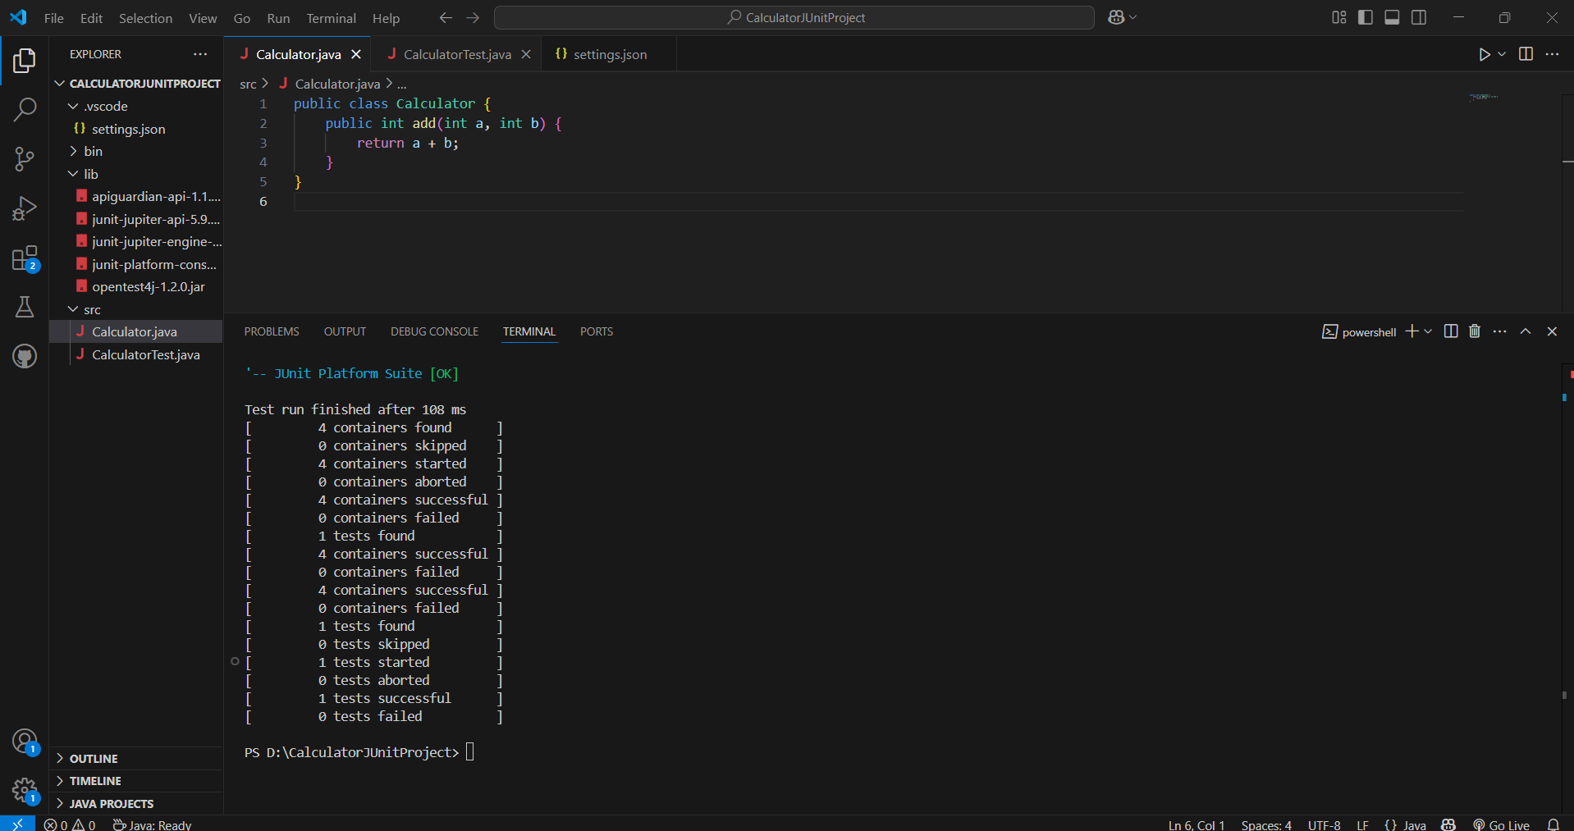

**Exercise 3: Assertions in Junit**

**MathUtils.java**

public class MathUtils {

public int multiply(int a, int b) {

return a * b;

}

public boolean isEven(int number) {

return number % 2 == 0;

}

public String getNullValue() {

return null;

}

public int[] getArray() {

return new int[]{1, 2, 3};

}

}

**MathUtilsTest.java**

import static org.junit.jupiter.api.Assertions.*;

import org.junit.jupiter.api.Test;

public class MathUtilsTest {

MathUtils utils = new MathUtils();

@Test

public void testMultiply() {

assertEquals(20, utils.multiply(4, 5));

}

@Test

public void testIsEven() {

assertTrue(utils.isEven(10));

assertFalse(utils.isEven(11));

}

@Test

public void testNullValue() {

assertNull(utils.getNullValue());

}

@Test

public void testArrayEquality() {

assertArrayEquals(new int[]{1, 2, 3}, utils.getArray());

}

}

**Output:**

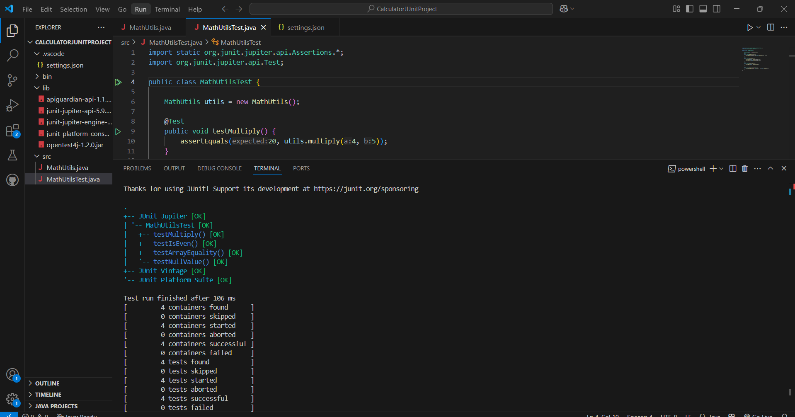

**Exercise 4: Arrange-Act-Assert (AAA) Pattern, Test Fixtures, Setup and Teardown Methods in JUnit**

### BankAccount.java

public class BankAccount {

private double balance;

public BankAccount(double initialAmount) {

this.balance = initialAmount;

}

public void deposit(double amount) {

balance += amount;

}

public boolean withdraw(double amount) {

if (amount > balance) return false;

balance -= amount;

return true;

}

public double getBalance() {

return balance;

}

}

### BankAccountTest.java

import static org.junit.jupiter.api.Assertions.*;

import org.junit.jupiter.api.*;

public class BankAccountTest {

BankAccount account;

@BeforeEach

public void setUp() {

account = new BankAccount(1000.0); // Arrange

System.out.println("== Setup executed ==");

}

@AfterEach

public void tearDown() {

account = null;

System.out.println("== Teardown executed ==");

}

@Test

public void testDeposit() {

// Act

account.deposit(500);

// Assert

assertEquals(1500.0, account.getBalance());

}

@Test

public void testWithdrawSuccess() {

// Act

boolean result = account.withdraw(300);

// Assert

assertTrue(result);

assertEquals(700.0, account.getBalance());

}

@Test

public void testWithdrawFailure() {

// Act

boolean result = account.withdraw(2000);

// Assert

assertFalse(result);

assertEquals(1000.0, account.getBalance()); // Balance unchanged

}

}

**Output:**

